**Create ec2 instance**

Add security group and add pem file

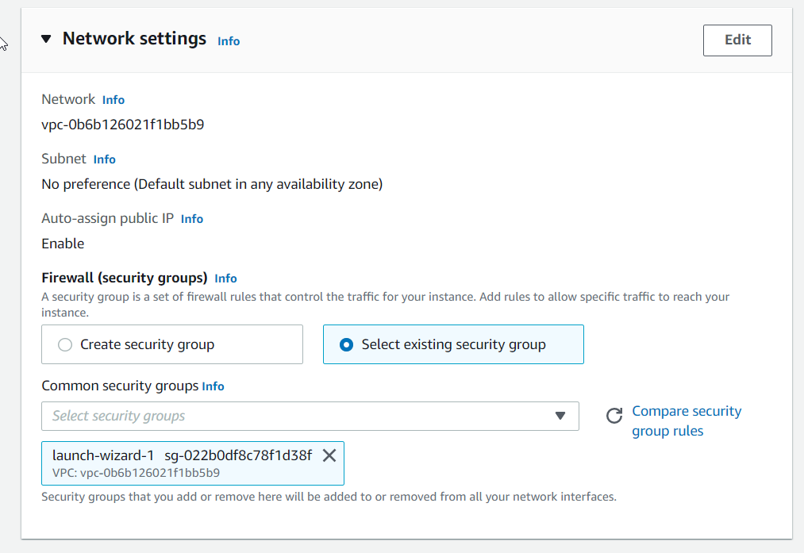

Make sure your security group has ssh,htttp and https.

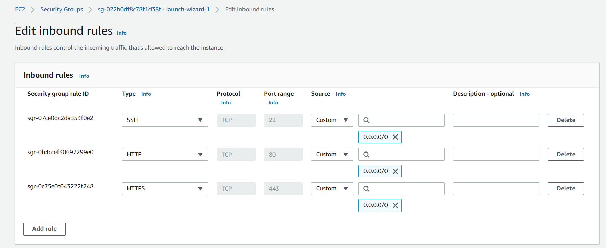

Advanced detail on user data

#!/bin/bash

# Use this for your user data (script from top to bottom)

# install httpd (Linux 2 version)

yum update -y

yum install -y httpd

systemctl start httpd

systemctl enable httpd

echo "<h1>Hello World from $(hostname -f)</h1>" > /var/www/html/index.html

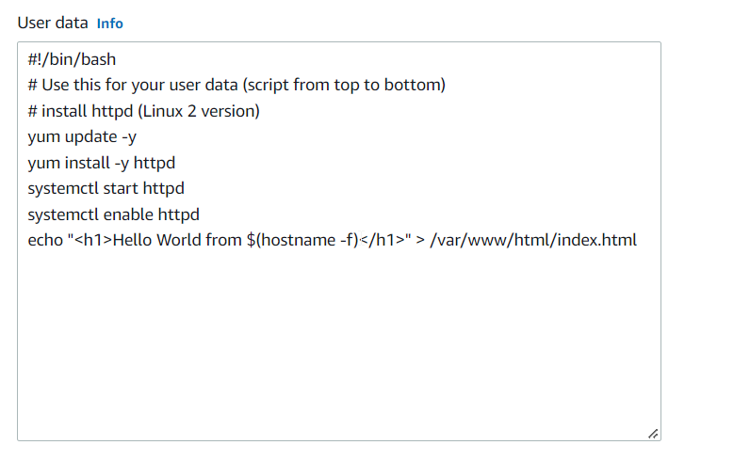

Keep other options default

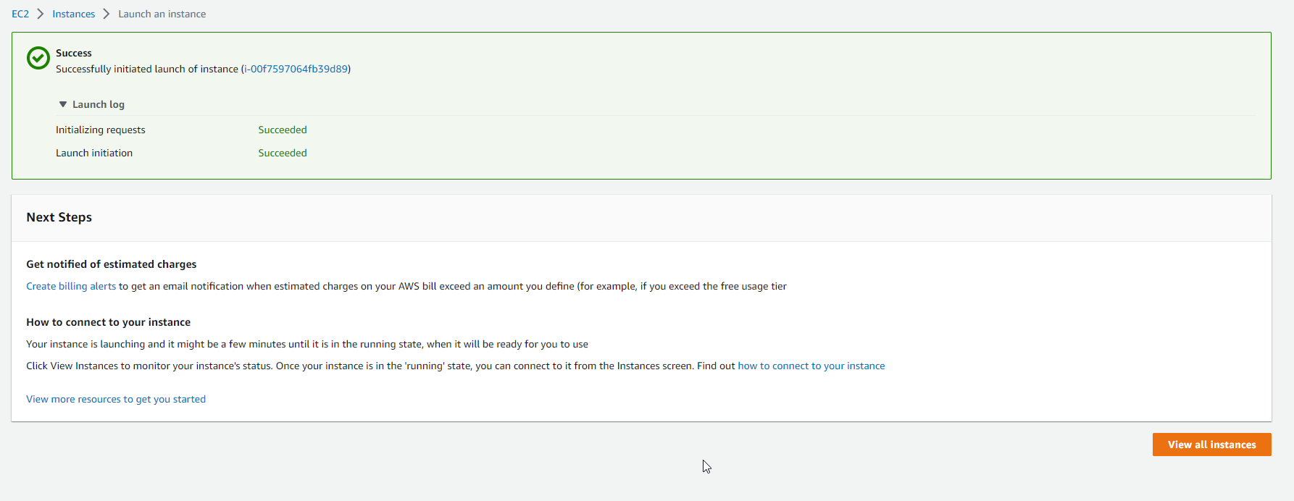

Go to load balancers in load balancing

* Click Create Load Balancer

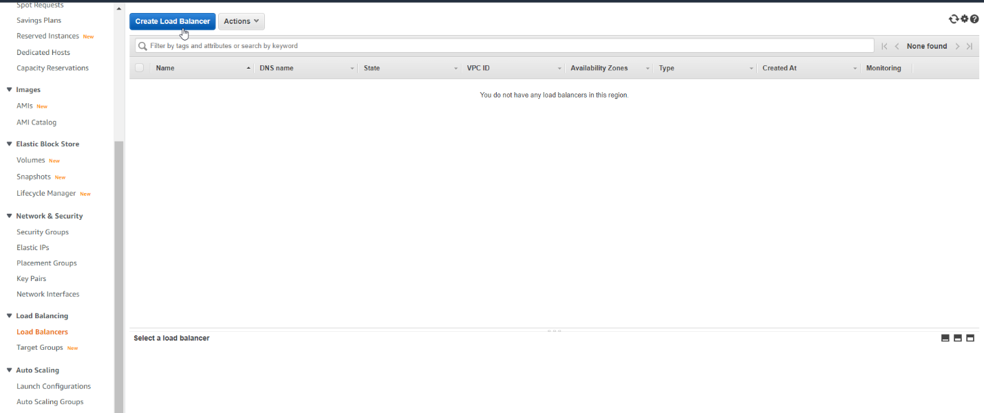

Chose Classic Load Balancer

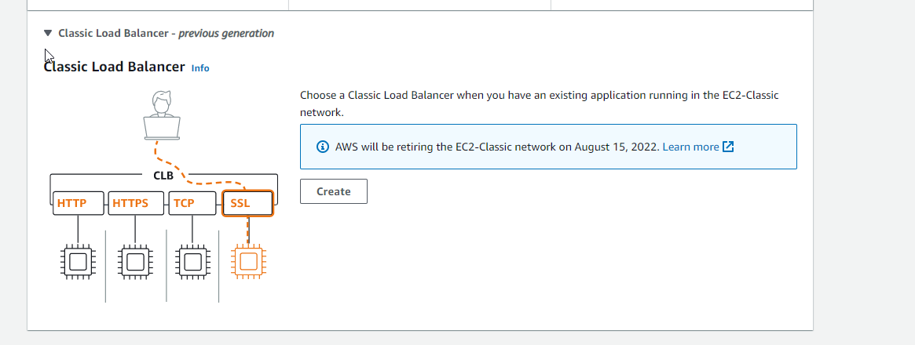

Name Load Balancer

Click Next Assign Security Group

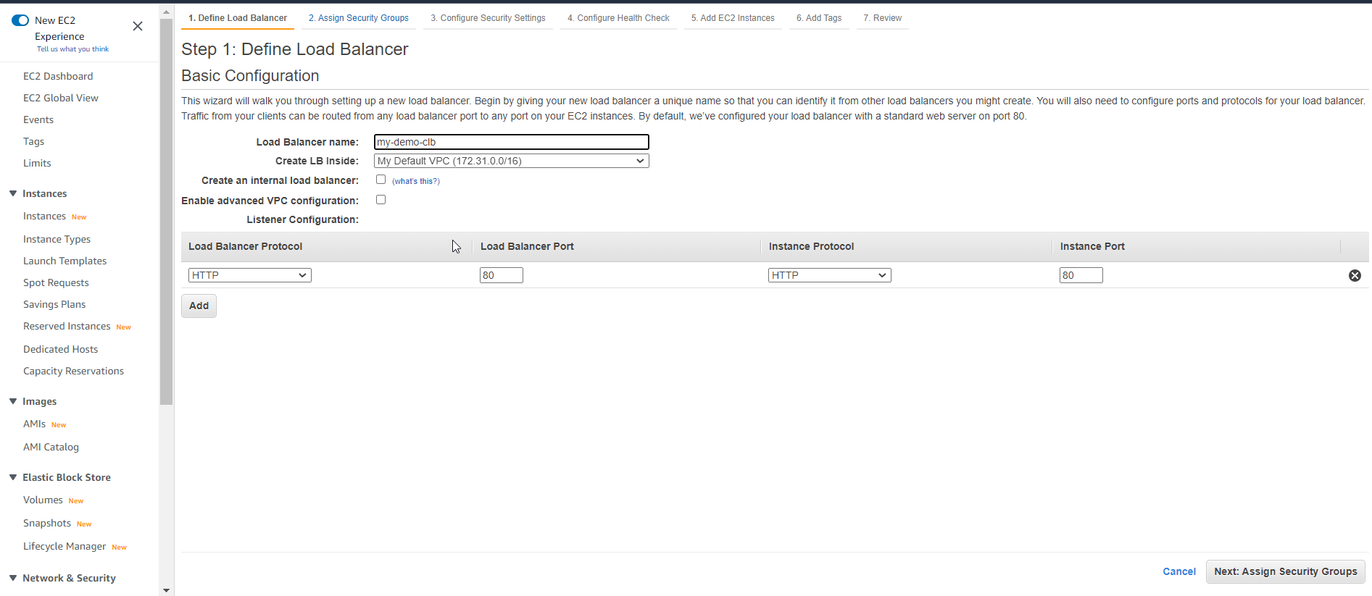

* Create new security group
* Click Next Configuration setting

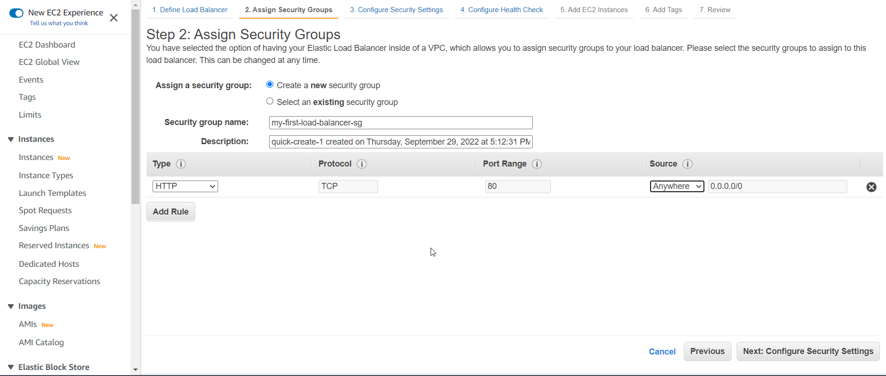

* Click Next

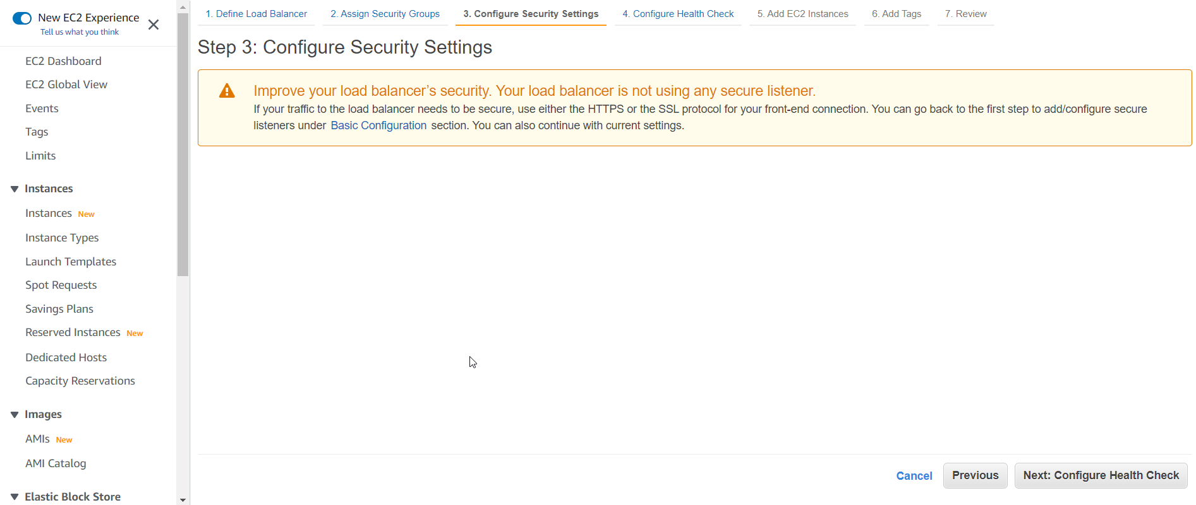

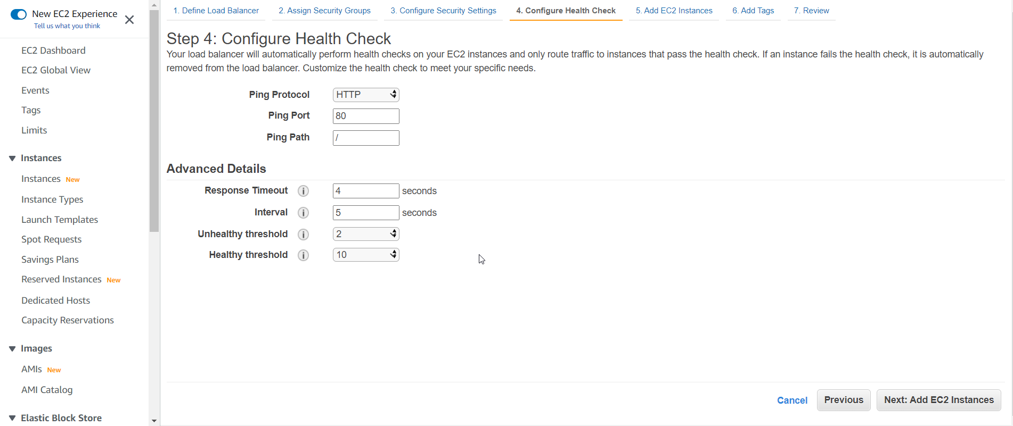

Copy paste your public ip address of ec2

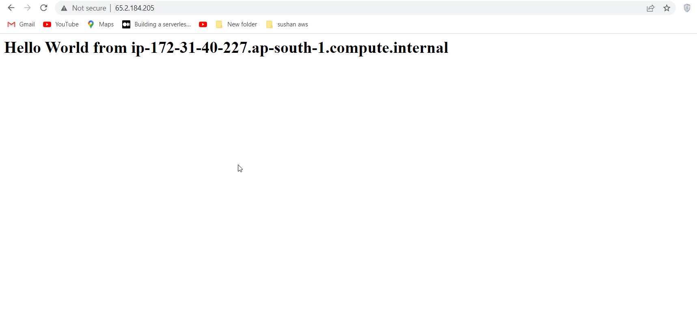

Select instance

Click Next

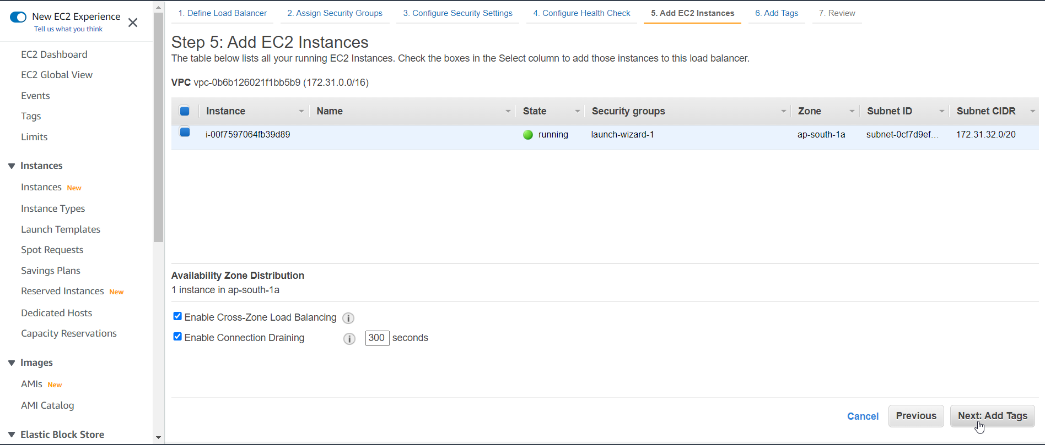

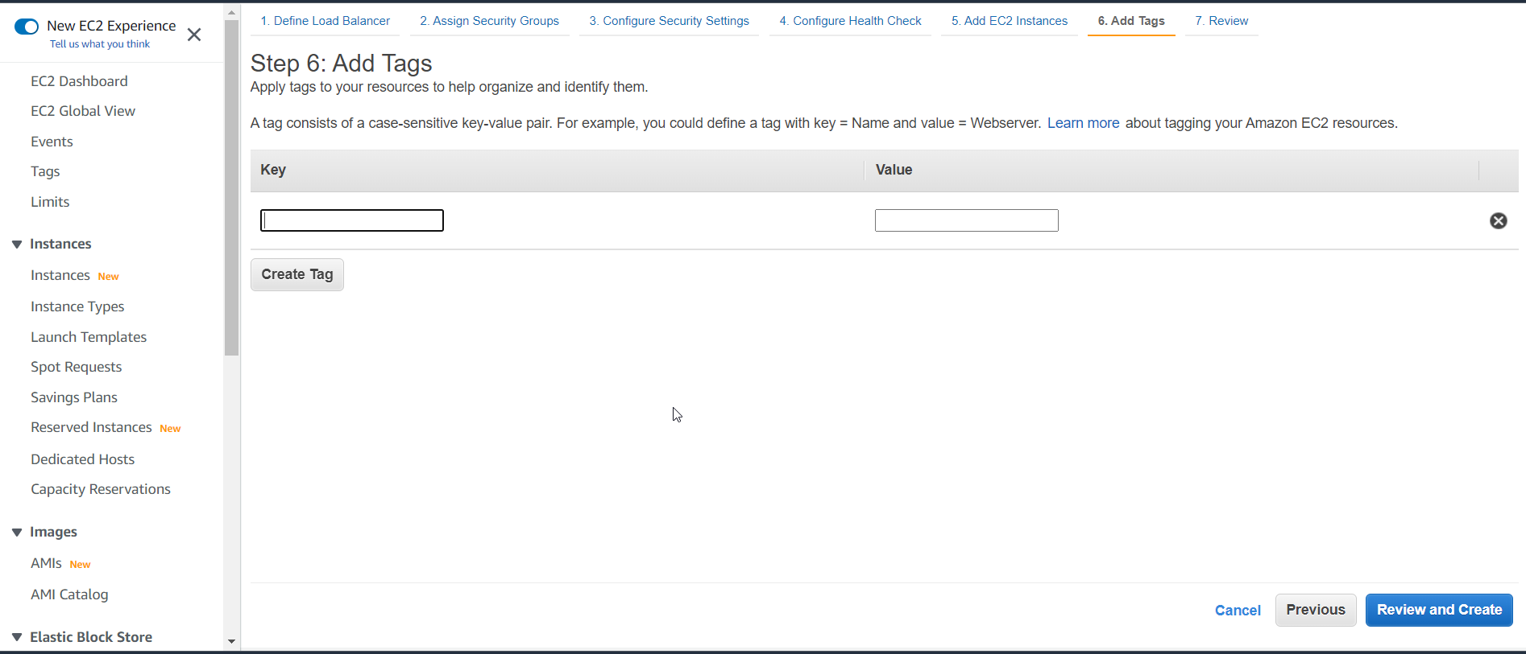

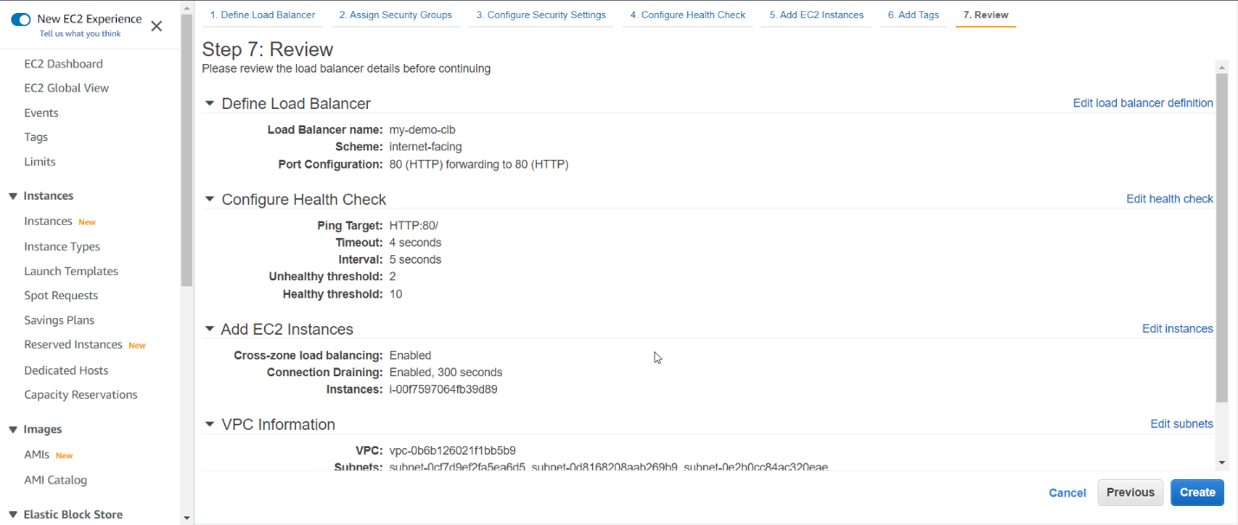

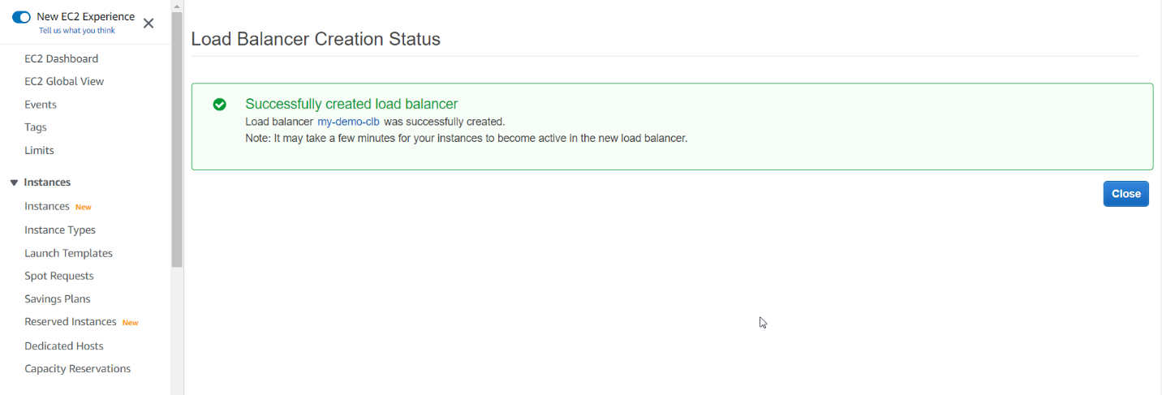

Open your load balancer

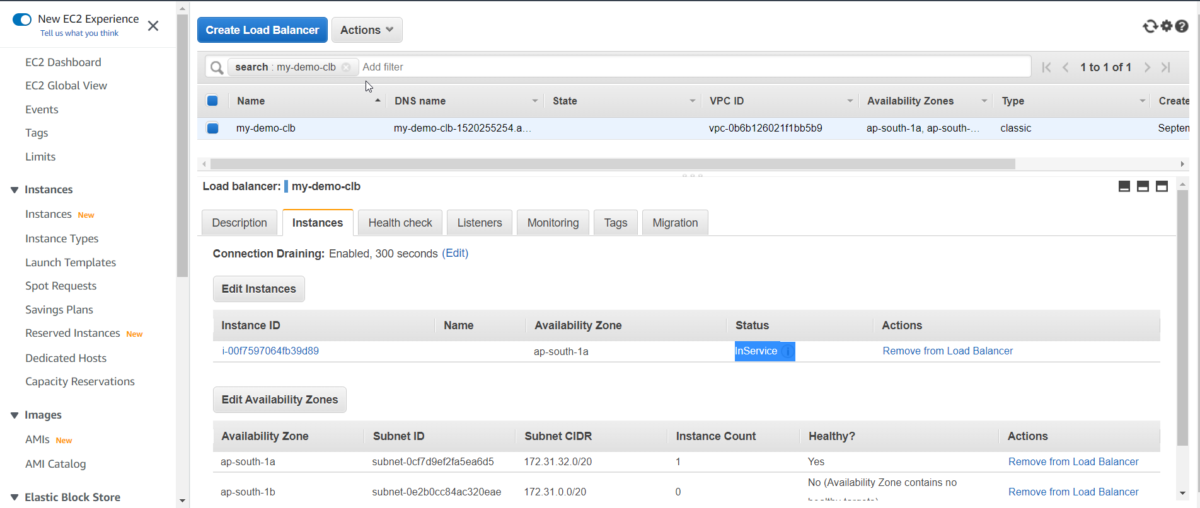

Copy your DNS and paste.

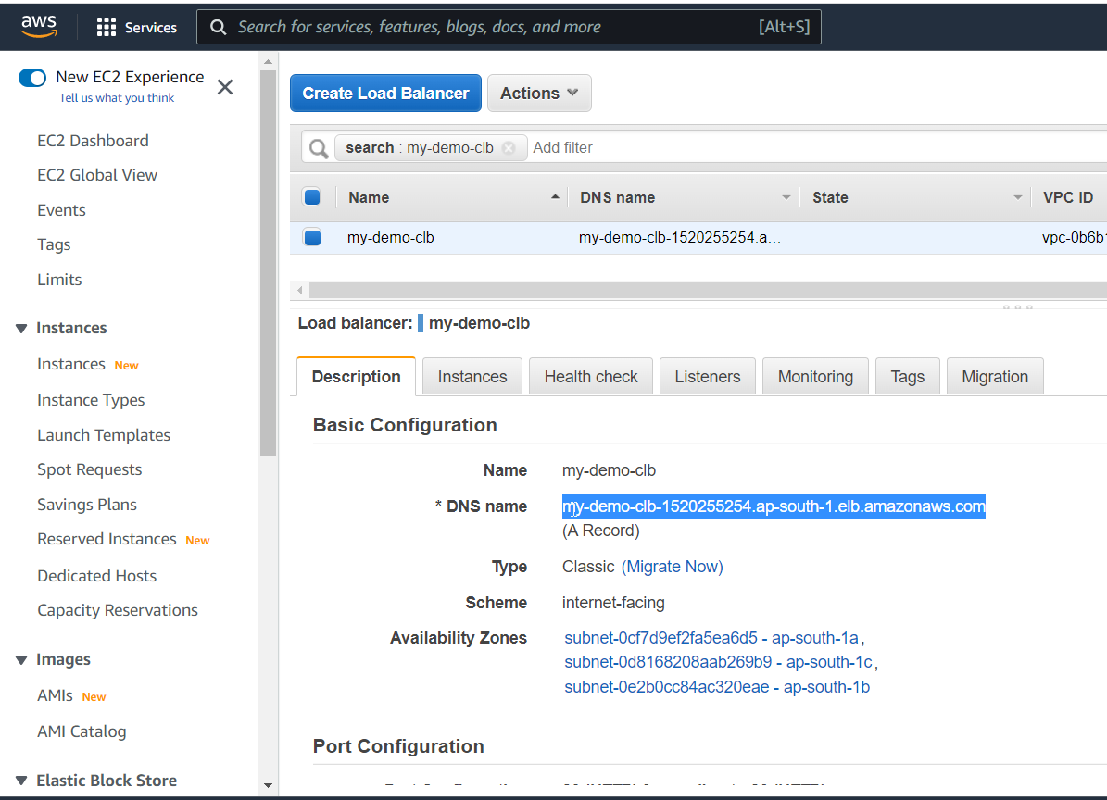

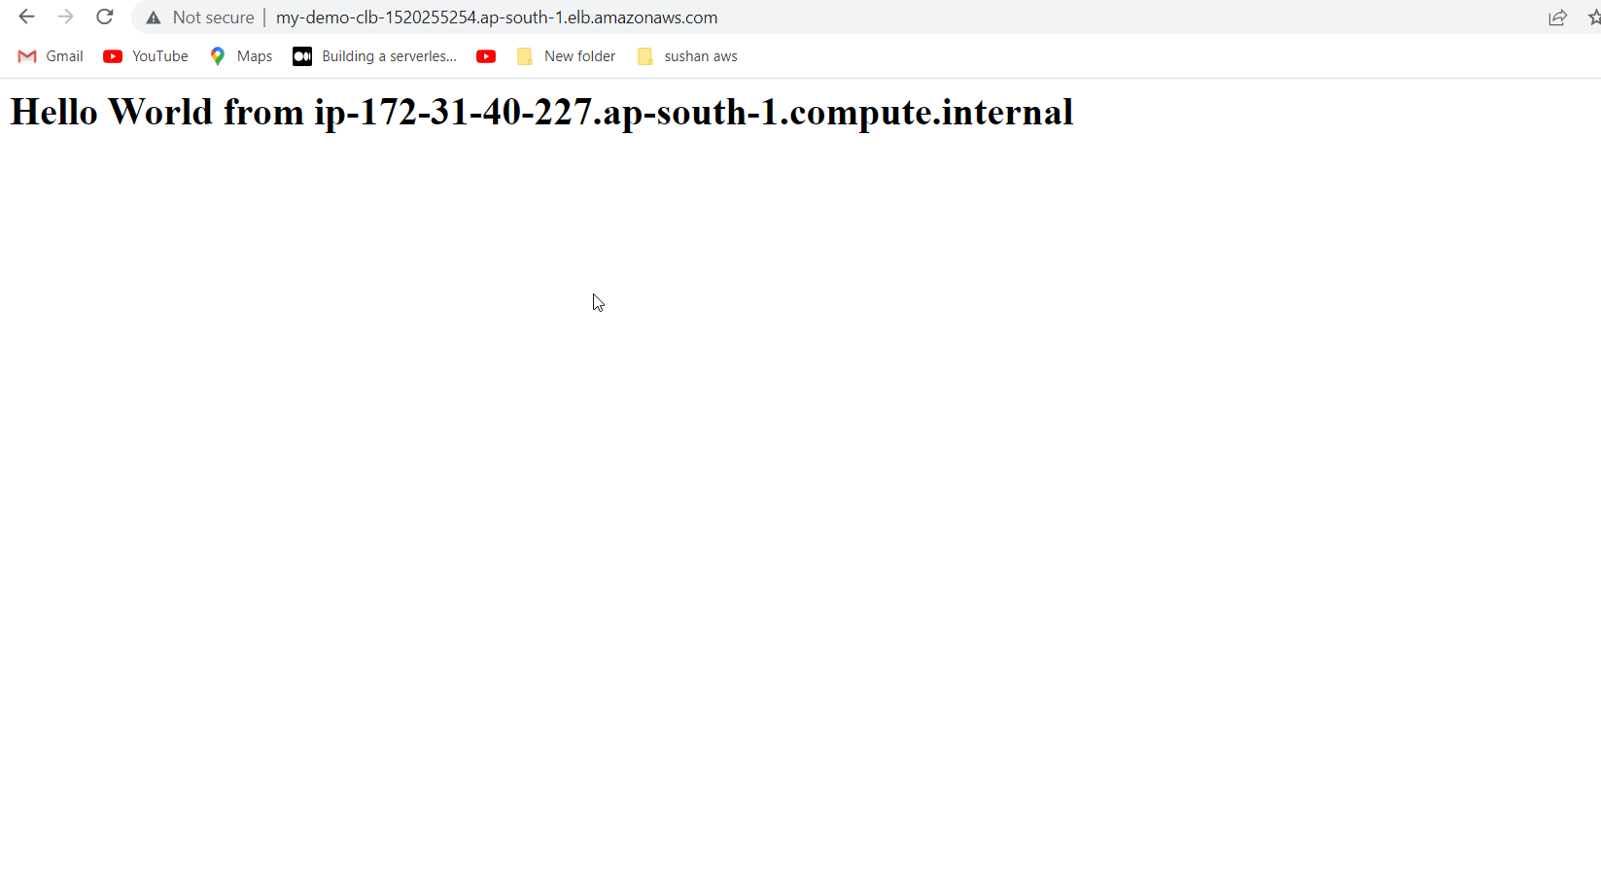

You may face issue on running load balancer due to security group inbound rules or bootstrap issue.

We have deleted port 80.er got this error.

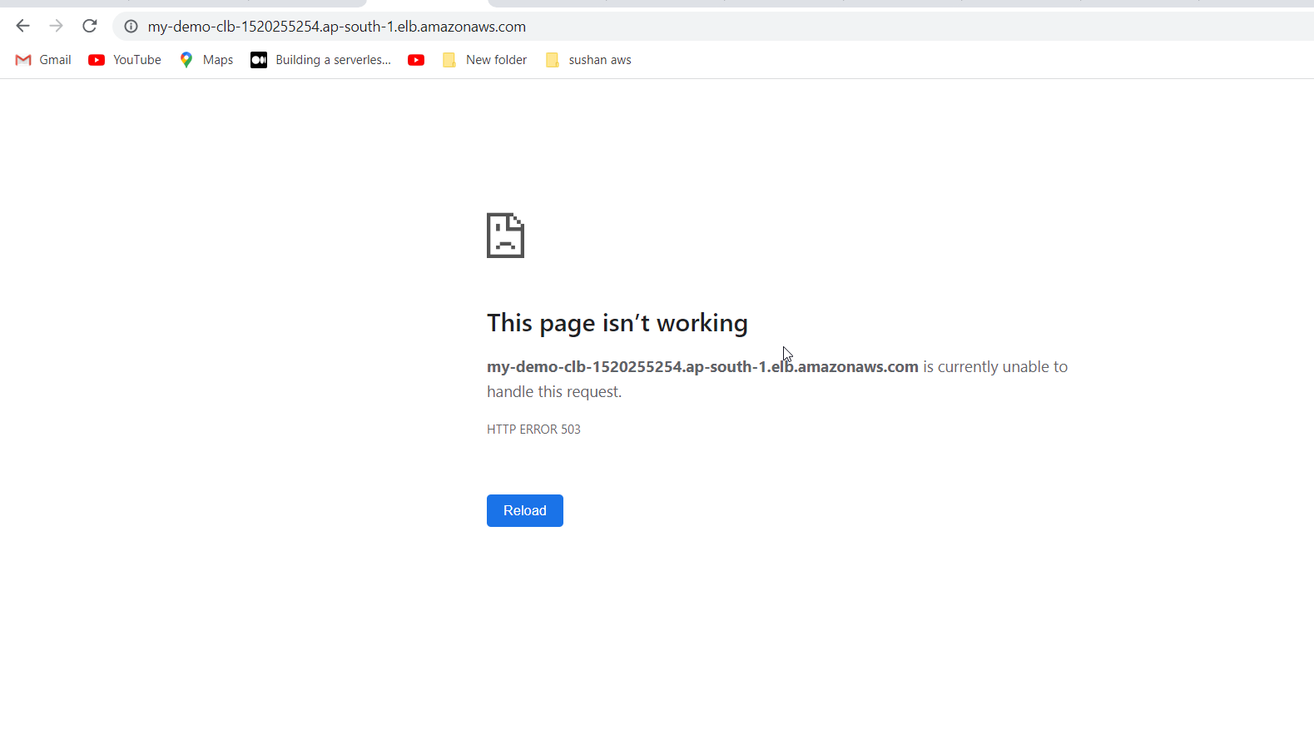

Go to security Group AND DELETE EXISTINNG INBOUND RULES

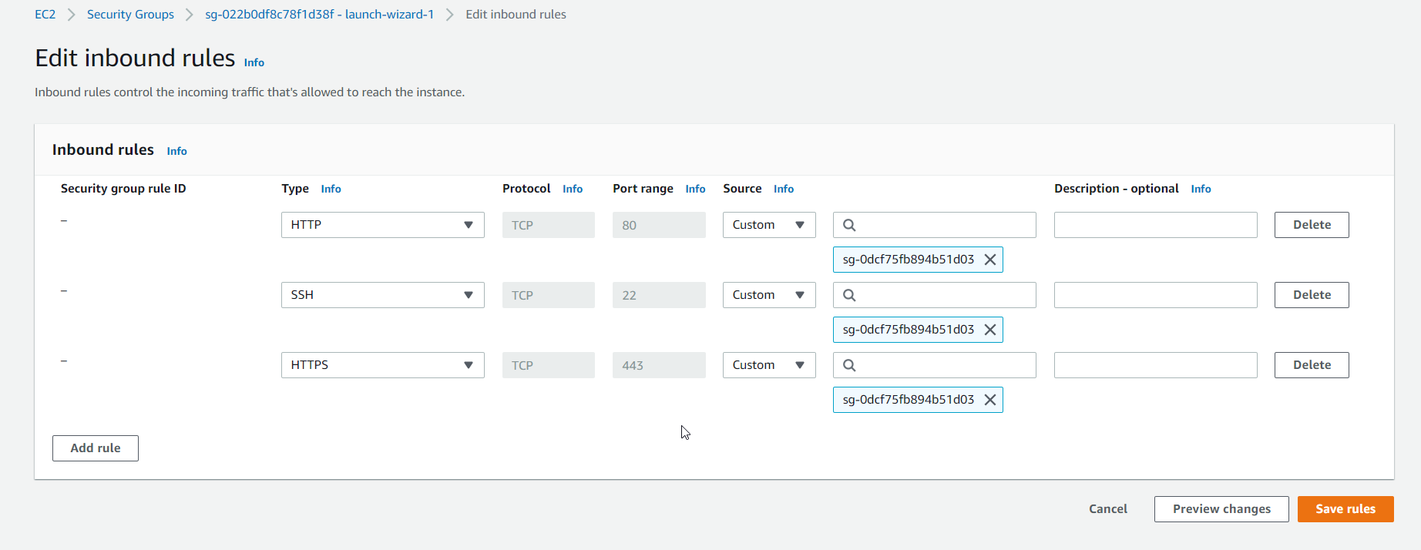

Right click and Launch instances

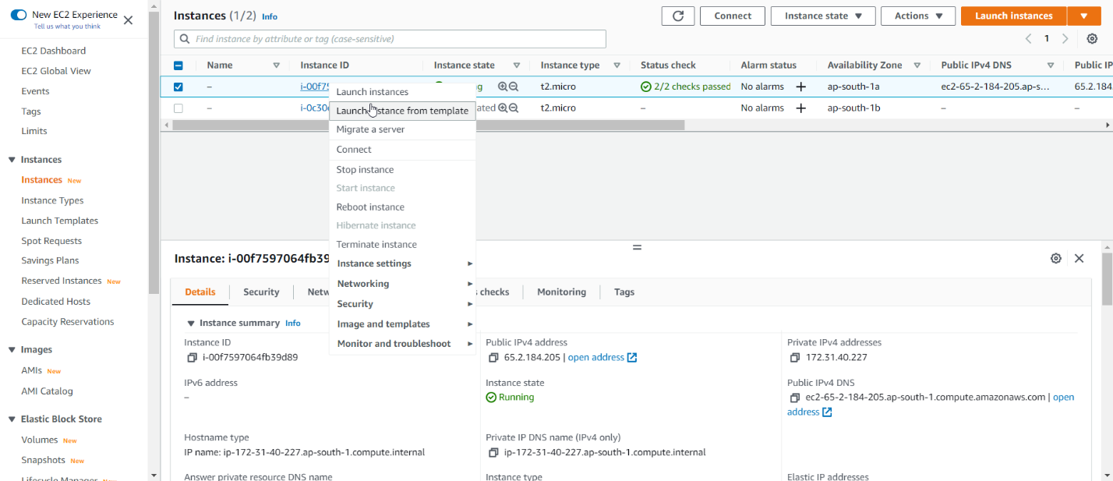

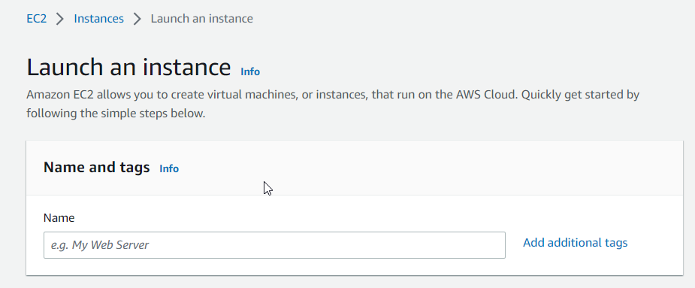

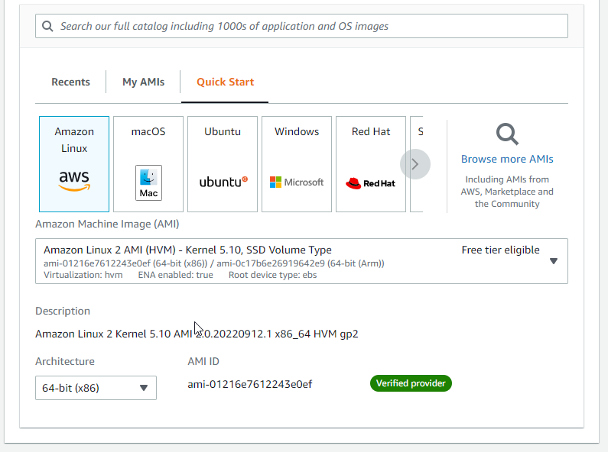

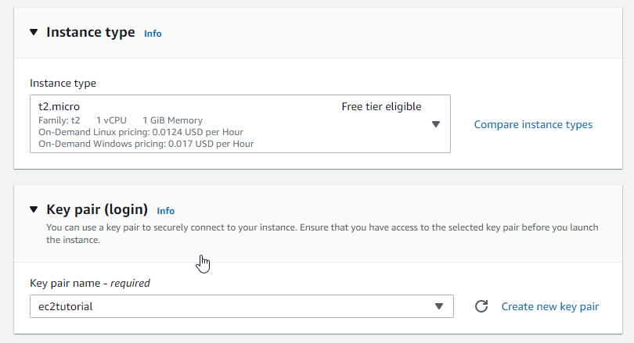

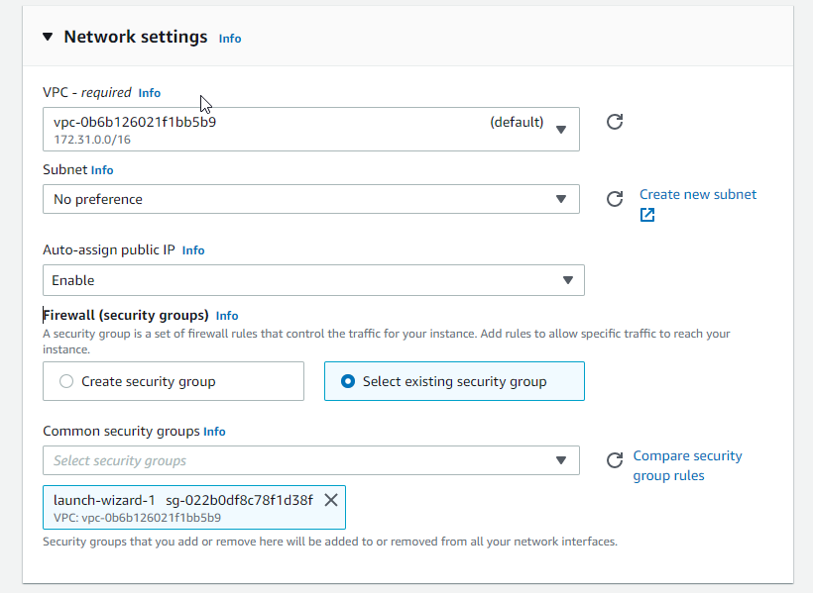

Go to advanced detail

#!/bin/bash

# Use this for your user data (script from top to bottom)

# install httpd (Linux 2 version)

yum update -y

yum install -y httpd

systemctl start httpd

systemctl enable httpd

echo "<h1>Hello World from $(hostname -f)</h1>" > /var/www/html/index.html

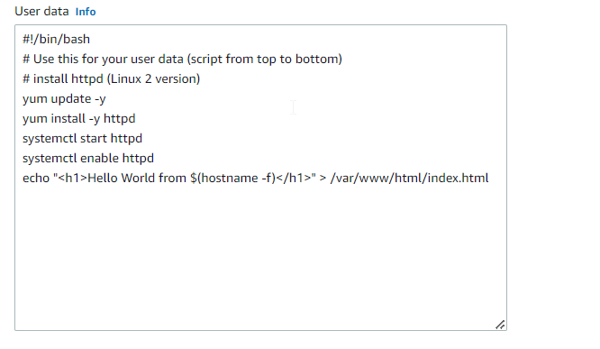

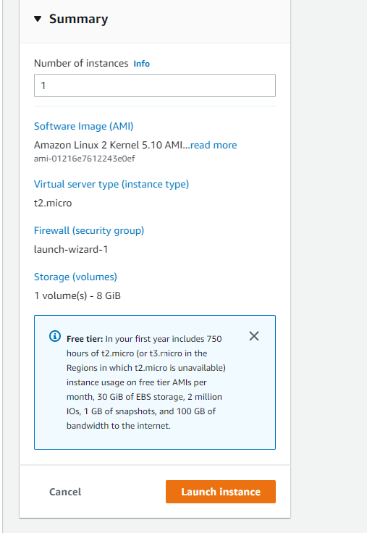

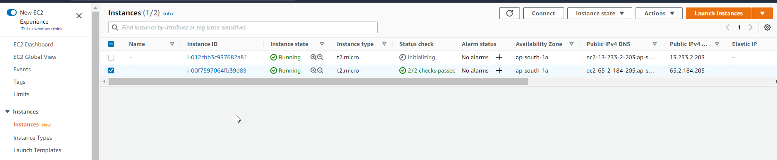

Again launch another instance

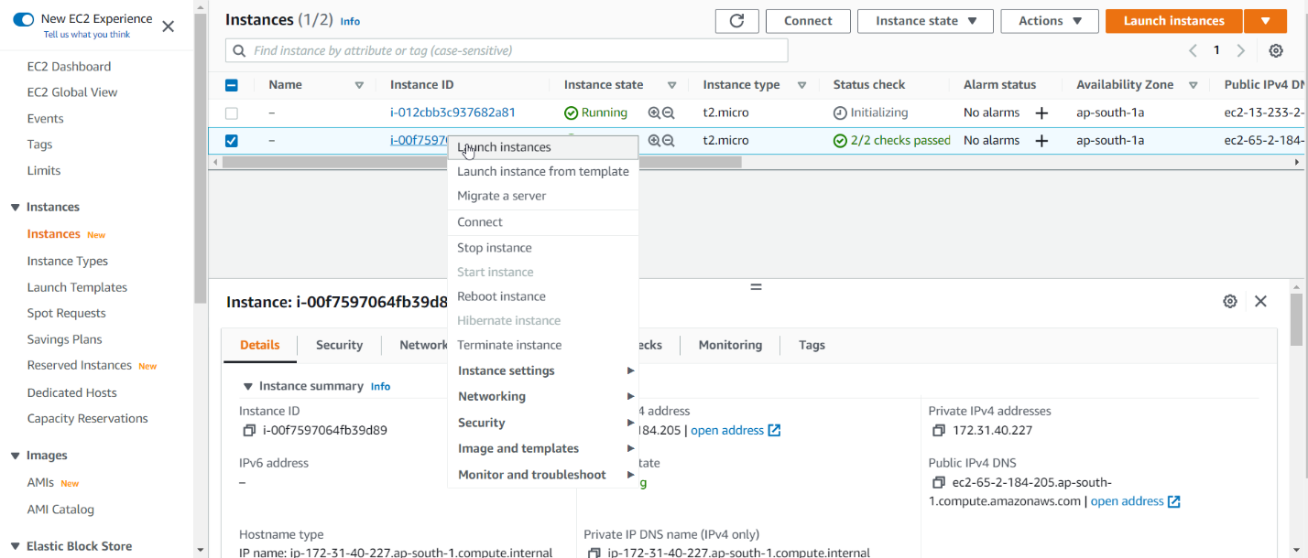

Again repeat same step

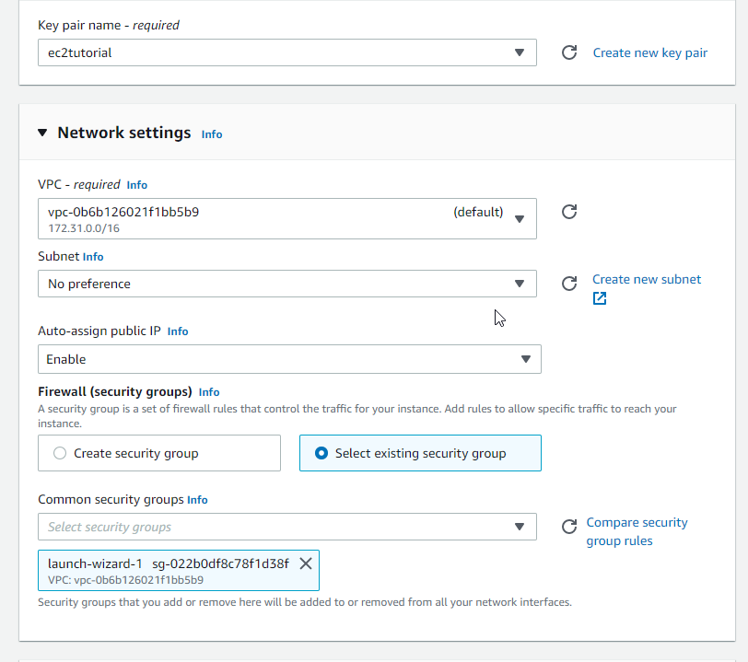

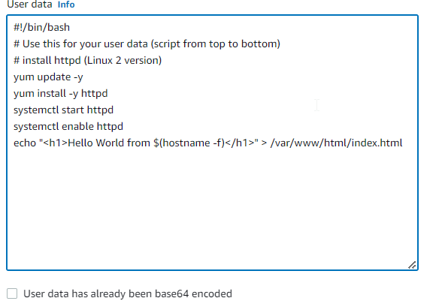

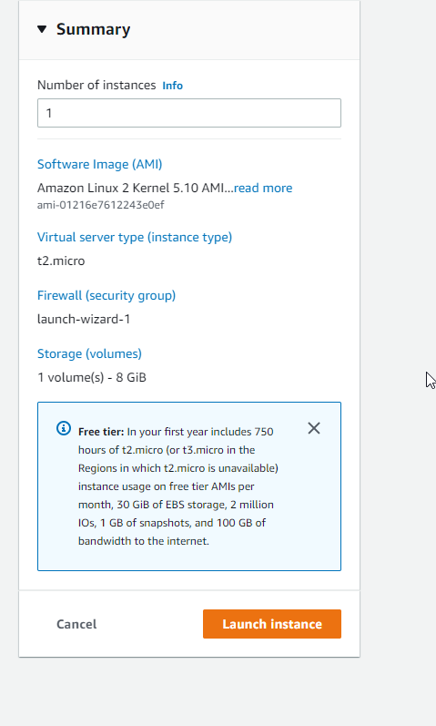

Now we have three ec2 instances

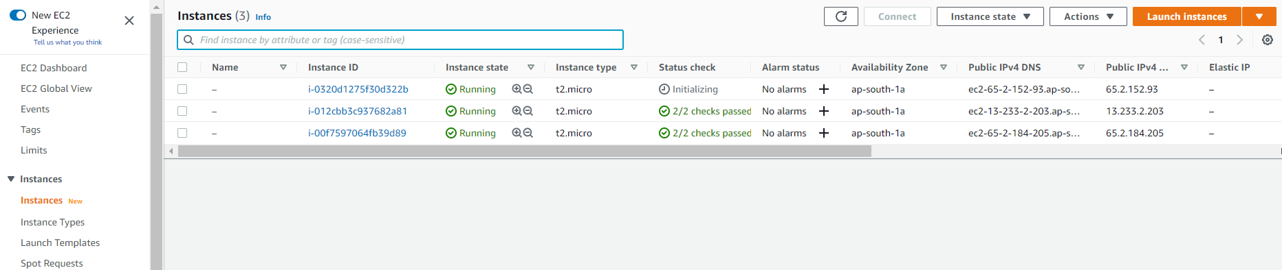

Go to load balancer on ec2 instance

Click edit instance

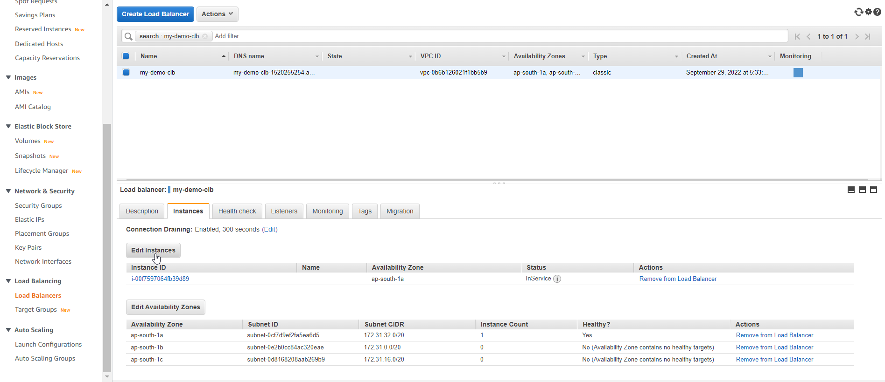

* Select and all instances
* Click save

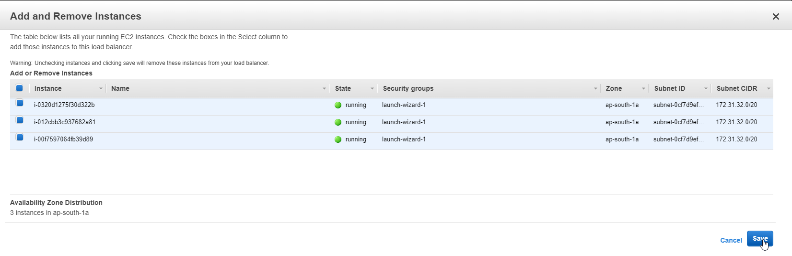

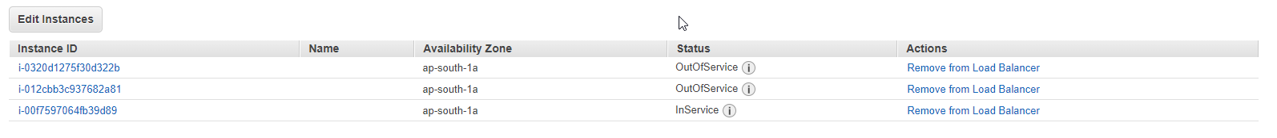

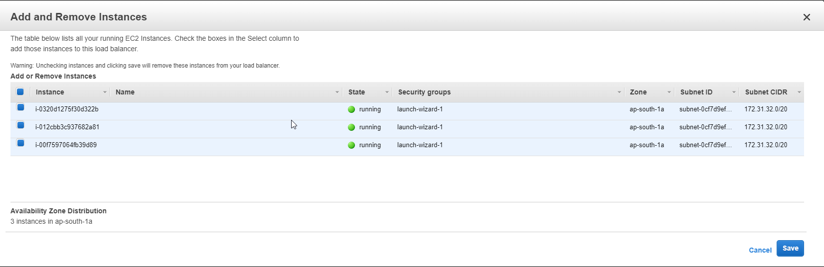

You will get different instance everytime you refresh







Delete load balancer

